SOCIAL STUDIES
GRADE: V DATE: 12.8.20
NAME:
7. The land of snow

Worksheet -7

I. Choose the correct Answer
1. The largest island in the world is _________________.
a. Australia b. Greenland c.Iceland
2. The jackets that Inuit’s wear are called _______________ .
a. Trench coats b .Shrugs c. Parkas
3. The original inhabitants of the country are called _______________ .
a. Mongols b. Aztecs c. Inuits
4. The capital and the largest city of Greenland is ___________ .
a. Nuuk b. Sisimiut c. Riyadh
5. Huge pieces of ice that break away from an ice sheet and pose danger for ships are called _____________
a. Ice cubes b. Ice bergs c. Snow
6. There is continuous sunlight for several weeks in the ______________ season.
a. Summer b. winter c .Autumn

II .Look at the picture. Answer all questions

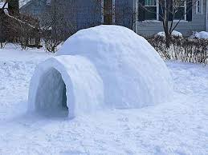
1. What type of house is shown in the picture?
________________________________________________________________
________________________________________________________________
2. What is it made of?
________________________________________________________________
________________________________________________________________
3. Describe the house from inside.
________________________________________________________________
________________________________________________________________
________________________________________________________________
________________________________________________________________

